Darrien Lee, Daniel Kim

Lab 1

**PART 1:**

Tutorial Screenshots:

* 1. Tutorial 1: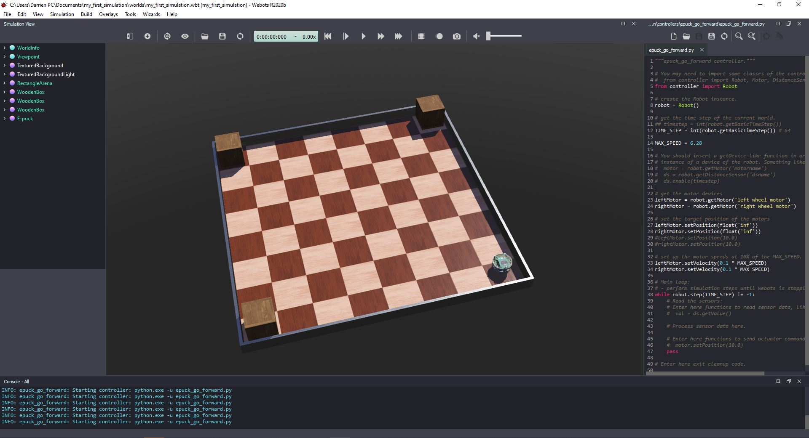
  2. Tutorial 2:

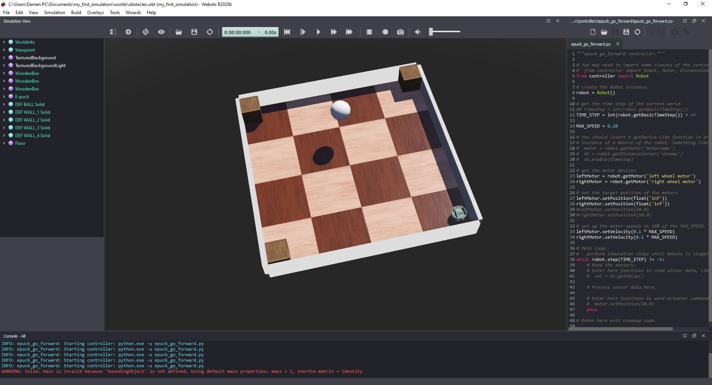

* 1. Tutorial 3:

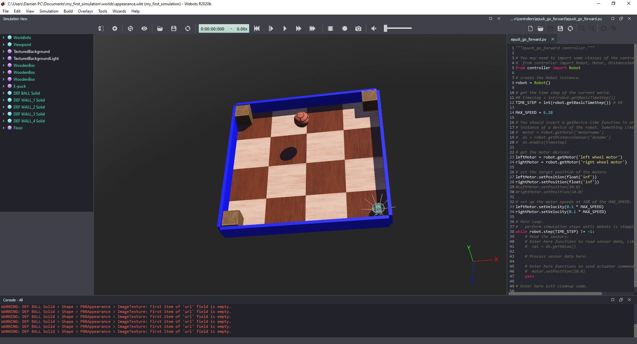

* 1. Tutorial 4:

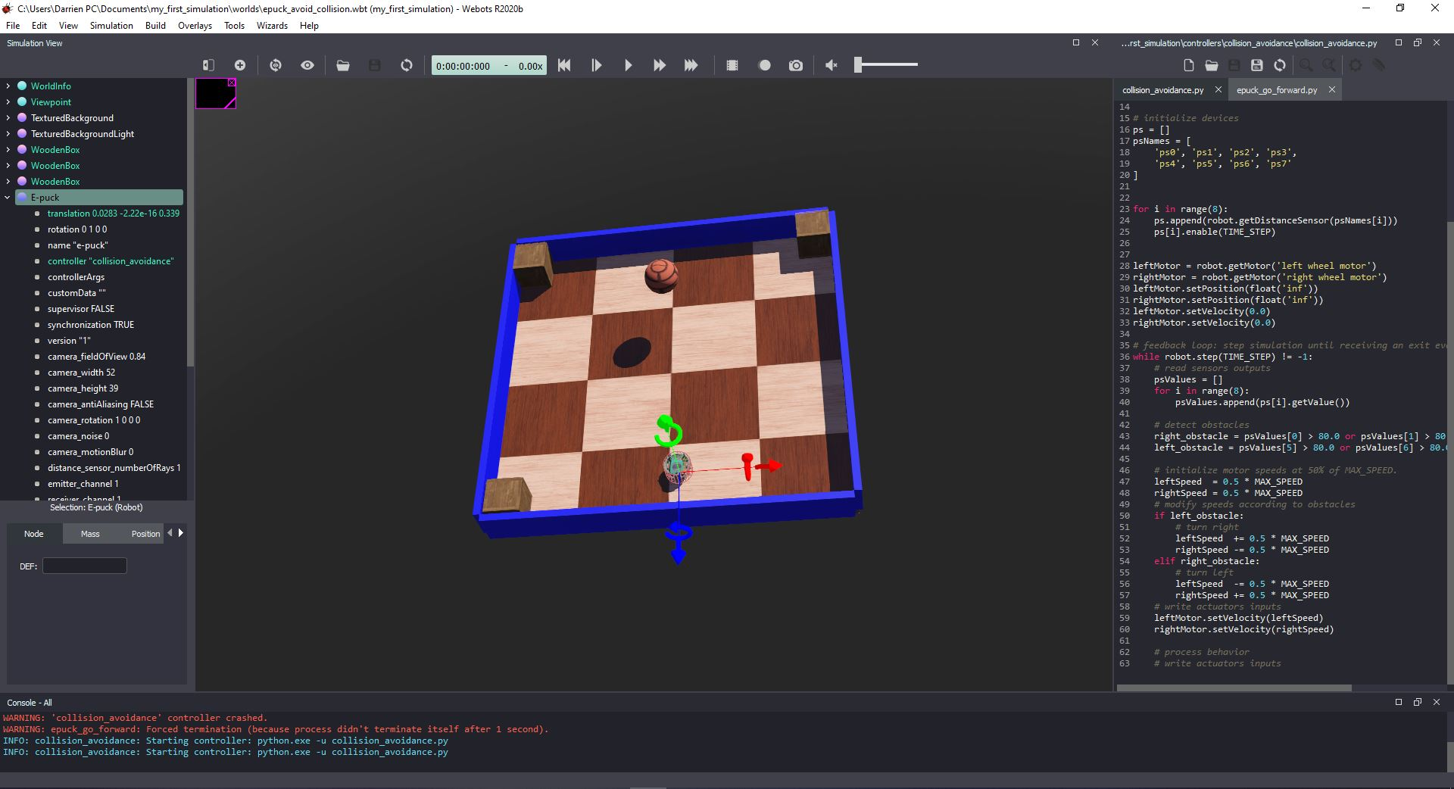

**PART 2:**

1. A drawing of your state machine. Make sure all the states and transitions are labeled and that it is faithful to your implementation.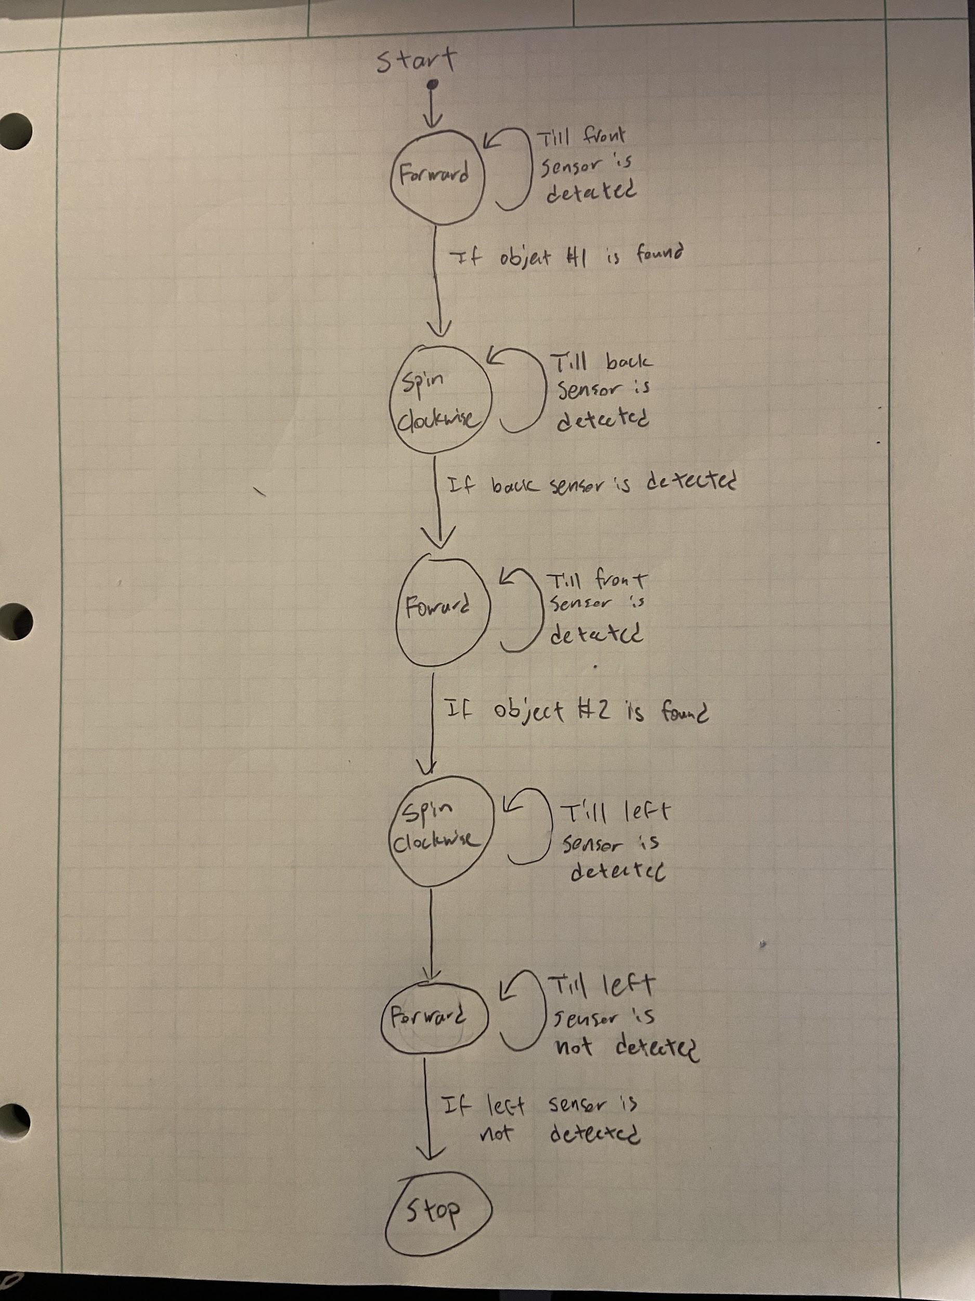
2. Were you able to get your controller to complete the task? If not, which parts failed? Why?
   1. Yes, all parts of the controllers work as intended. Initially, we had issues trying to rotate the e-puck 180 degrees and tried everything from setPosition to changing our if statements, and ultimately got it to work when we changed the ps values that each sensor was checking (instead of defaulting to > 80 for all sensors).
3. A statement indicating whether you have worked with Python before, and if so, describe your experience.
   1. Yes, we both have a little bit of python experience, but we are mostly familiar with c++ as most classes taught c++. However, it was easy to translate our c++ knowledge into python and have used python in a few classes before.
4. How much time did you spend programming Part 2 of this lab?
   1. We finished Part 2 of the lab in about 4 to 5 hours mainly because we had issues with rotating the e-puck to a certain number of degrees, as stated above. After solving that issue, the rest of part 2 was easily implemented.